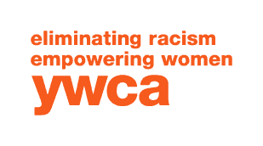

YWCA MALDEN CENTER FOR WOMEN AND FAMILIES

Group Leader

YWCA Malden is an innovative community-based organization with a mission of Empowering Women and Eliminating Racism. The organization’s unique programs are targeted to underserved low-income women, girls, and families of color in the urban community of Malden, Massachusetts

Position Description and Responsibilities
Group leaders should have work experience and/or educational background in group activities, planning daily programs and have an awareness of developmental characteristics of children (K-5) and how to meet their needs. Days and hours worked are based on the school calendar with extended hours on half days, school vacations and summer break.
The group leader will
- Actively engage and interact with children, with the goal of fostering the positive development of each child and the group.
- Supervise groups of children both small and large while building a positive relationship with the children that helps them to develop physically, socially, emotionally and cognitively.
- Work with co-workers to set goals, objectives and guidelines for program.
- Enforce licensing guidelines and regulations.
- Supervise youth during school bus transportation.
- Create an environment that supports a diverse range of activities and interests.
- Maintain positive teacher, parent, and student communications that convey respect, support and trust.
- Reports to the Director of Children’s Services.
- Some other duties may be reassigned, and other duties may be assigned as required by the Director of Children’s Services.

Qualifications
- 18 years of age or older
- Desire and ability to work with children in a nurturing and safe environment.
- Enthusiasm, creativity, good moral character, patience, and self-control.
- Ability to accept supervision and guidance.
- Prior paid experience working with children and/or educational background in human services, social work, or other related fields.
- CPR/First Aid certified required or must be willing to become certified within the first 30 days of employment.
- Ability to work flexible hours is required.

YWCA Malden is an Equal Opportunity /Affirmative Action/Immigration Reform and Control Act/American with Disabilities Act Employer.

YWCA Malden is dedicated to eliminating racism, empowering women and promoting peace, justice , freedom and dignity for all.

